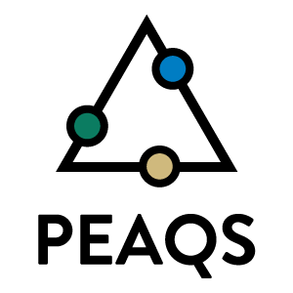
10b. HIGHLIGHT
Title: Building PEAQS Community
Highly collaborative projects are built by our diverse team to utilize each institution’s unique strengths to advance education of undergraduates and novel material science research. A strong center community and confident, empowered undergraduate researchers is necessary for the success of PEAQS students and collaborative research and education projects. In the first nine months PEAQS strengthened the community through cross institutional exchanges of faculty, staff, and students between PEAQS and STROBE nodes as well as engaging students early and often in high impact activities.
Already, the PEAQS research community has been strengthened through six cross-institutional exchanges involving >17 different faculty, staff, and students. These visits have been instrumental to building a strong research community and setting up long-term research collaborations across the PEAQS nodes. Additionally, in the first nine months of PEAQS, students had the opportunity to be engaged in numerous high impact activities that will have a direct impact on their research, peer network, scientific network, and scientific communication skills – all of which will give them the confidence they need to be successful students and scientists (Fig 12). In March 2019, two students from Fort Lewis College (FLC), James Sumpter and Tommy Swimmer, worked in Markus Raschke’s lab at CU Boulder for a week. Under the mentorship of Markus Raschke and the graduate students in his group, James and Tommy gained technical experience and confidence necessary to continue their research at FLC. Also in March 2019, Baldwin Varner from Norfolk State University (NSU) was selected to give an oral and poster presentation at the national SPIE conference in Denver, CO. This highly impactful experience gave him vital scientific communication skills and confidence that will help him throughout his career.
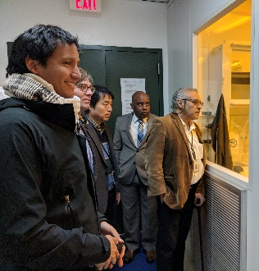
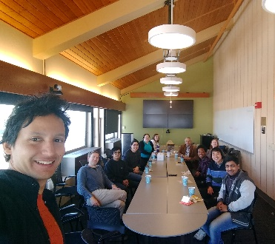
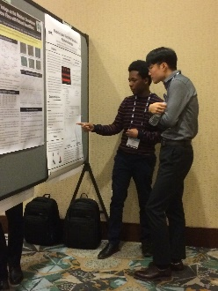
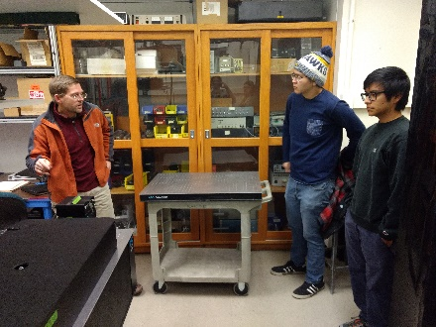
Students at both FLC and NSU have also had the opportunity to develop their peer network and practice their scientific communication skills through weekly technical meetings. At these meetings, students get first-hand experience in discussing their current research and future plans among peers and advisors. Creating these opportunities for students to engage with one another creates an expansive network for these students that allows them to become peer mentors and prepares them for future career opportunities beyond their bachelor’s degree.

Figure 12. (From left to right) FLC students, James Sumpter and Tommy Swimmer, tour Markus Raschke’s lab in preparation for their week-long project. Baldwin Varner presents his poster at SPIE conference. Faculty, staff, and students from all three nodes meet to discuss collaborations. Jorge Nicholas Hernandez Charpak, Ryan Haaland, Chris Regan (not pictured), and Sarah Schreiner (not pictured) tour NSU’s clean room facilities.

